CS 255 System Design Document Template

UML Diagrams

UML Use Case Diagram

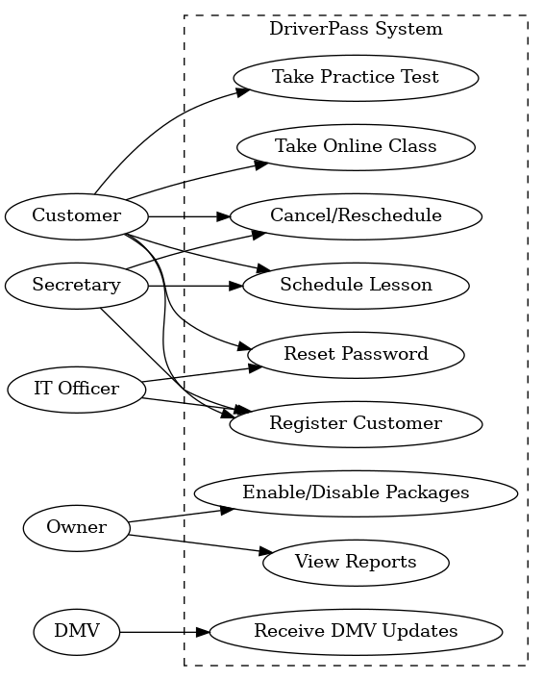

UML Activity Diagrams

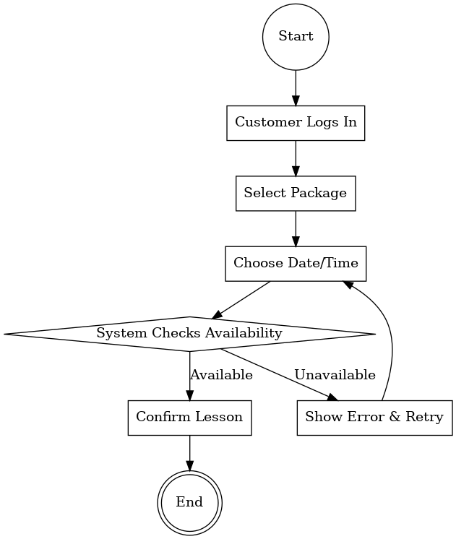

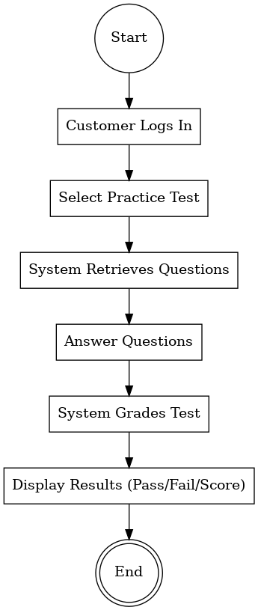

UML Sequence Diagram

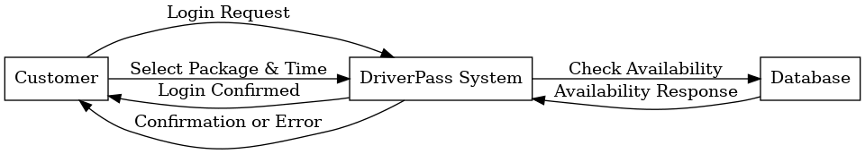

UML Class Diagram

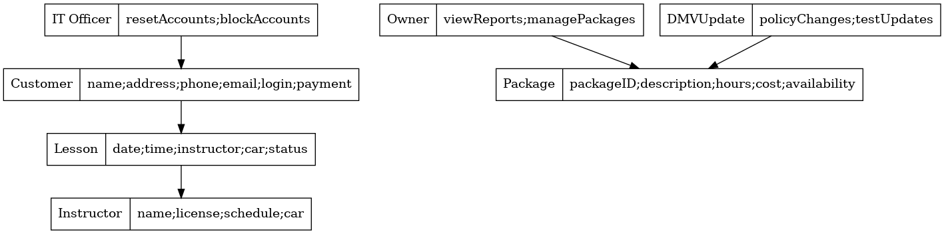

Technical Requirements

Hardware:
- Cloud server hosting (VMs or managed hosting environment)
- Secure database server
- Workstations/laptops for staff
- Mobile device access for customers
Software:
- Web-based application built on secure cloud platform
- Database management system (SQL-based)
- Integration with DMV update feed
Tools:
- Lucidchart/draw.io for diagrams
- GitHub for version control
- Microsoft Office/Google Docs for documentation
Infrastructure:
- Secure cloud storage for customer data
- Multi-level access control (Owner, IT Officer, Secretary, Customer)
- Automated backups and disaster recovery
- Secure payment processing integration

